Adobe Flash CS4
City Animation

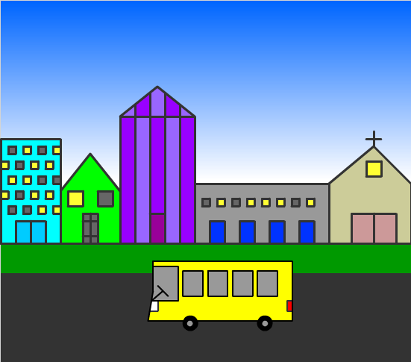

1. Open Adobe Flash CS4 and click on Create New Flash File (ActionScript 3.0).
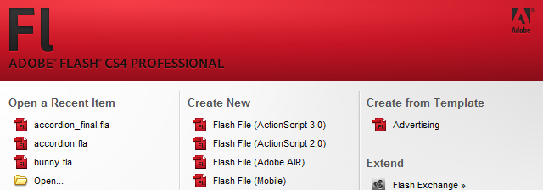

2. Go to View > Grid > Show Grid to make sure it is checked.
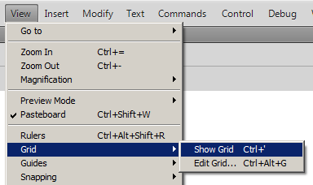

3. Go to Window > Library and make sure it is checked and open if it is not. This is where you will be storing all of the symbols you create.
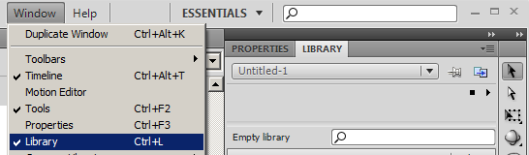

4. Next you will begin drawing parts to your vehicle. First you will draw a hubcap. Go to View > Snapping > Snap to Grid and make sure it is checked if it is not.
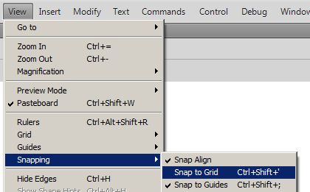

5. Choose the Oval tool from the toolbar.
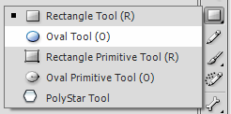

6. Change the stroke and fill colors to a gray for the hubcap.
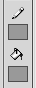

7. On the Properties panel, change the stroke number to 1.
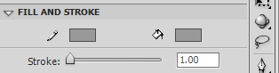

8. You may need to zoom in once or twice to draw your hubcap (don't forget to click on the oval again if you use zoom). Click in the upper corner of a square of a grid in the middle of the stage. Hold down the Shift key and drag diagonally to draw a circle. The circle should snap to the grid and you should only use one square for the hubcap.

9. Choose the black selection arrow and double click the hubcap to select both the fill and stroke. The hubcap should fill with white dots once selected.

10. Go to Modify > Convert to Symbol.
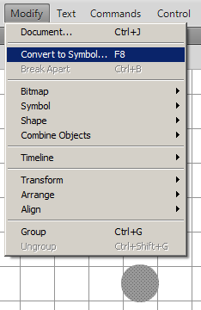

11. Type Cap as the name and choose Graphic as the type and click OK. The Cap symbol should now appear in your Library.
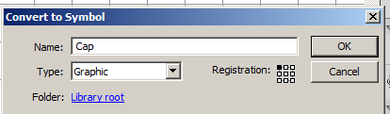
12. Make sure the Cap symbol is still selected on the stage and press Delete to remove it. AND make sure the Cap symbol is still in the Library.

13. Next we will draw the tires. Make sure to zoom back out so you can see the whole stage. Click on the Oval tool on the toolbar and change the fill and stroke colors to black.
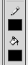

14. Starting in the upper left corner, click and drag to create a black circle for your tire that covers 9 squares. Repeat to create a second tire, positioning the tires apart from each other to create the base for your car.

15. Choose the line tool on the toolbar and make sure that Style is Solid on the Properties panel and change the Stroke to 3.00.
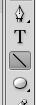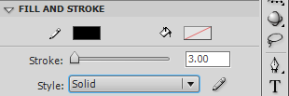

16. Draw the outline of your chosen vehicle by clicking and dragging out your lines. Your vehicle can be a sports car, van, school bus, etc. Use the lines of the grid on the stage as your guide and the lines will snap to the guides.
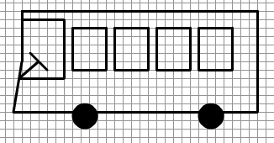

17. Next you need to "paint" your vehicle. Click on the Paint Bucket tool on your toolbar and then choose a color for your vehicle from the Fill color box.
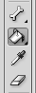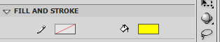

18. Color your vehicle by clicking on the various parts you want to color and changing the colors as necessary. Keep in mind the Paint Bucket tool will not work if your lines do not meet as it only "fills in" closed areas. Either fix your lines or use the Paint Brush tool.

19. Next you will add your hubcaps to the wheels. Choose the black selection arrow and click on the Library tab. Then click on the icon next to the Cap and drag a copy of the hubcap to your wheel. Use the arrow keys on the keyboard to adjust the location. Repeat the step for the other tire.
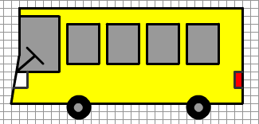

20. Now we need to group the items in the vehicle to make it a single object. Select the black arrow from the toolbar and click and drag a rectangle around the entire vehicle to select everything. The whole vehicle should be dotted.

21. Go to Modify > Group to group all of the items together.
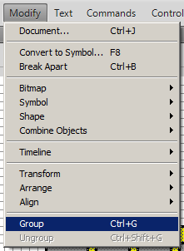

22. Go to Modify > Convert to Symbol to make the whole vehicle a single symbol.
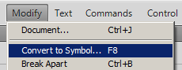

23. Type Car for the Name and choose Graphic for the Type and click OK. Now the vehicle should be a symbol in the Library. Make sure it is! Then with the vehicle still selected on the canvas, press Delete to remove it from there.

24. Time to draw your city!!! Chose the Line tool from the toolbar and change the stroke to 3.00 on the Properties panel. Draw various buildings on your canvas making sure to leave room for a sky, grass, and a road. You may want to zoom in to get better detail!
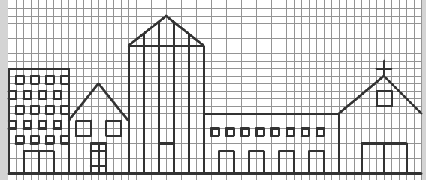

25. Again, you need to color your buildings. Using the Paint Bucket tool or the Paint Brush if you have to, color in your buildings, doors, and windows. Remember you may want "the lights on" in some windows.
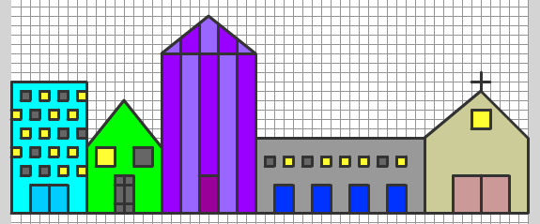

26. Double-click Layer 1 on the Timeline and name the layer Buildings.
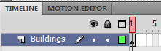

27. Next we will create the skyline. Select Insert > Timeline > Layer.
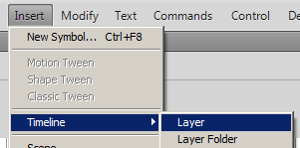

28. Double-click Layer 2 on the Timeline and name the layer Sky
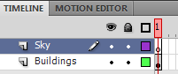

29. Making sure you are on the Sky layer (should be highlighted blue), select the Rectangle tool on the toolbar.
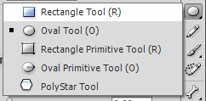

30. You will need your color swatches open in order to create a faded sky. Go to
Window > Swatches and make sure it is checked and open. On the Swatches panel, click the first gradient box at the bottom.
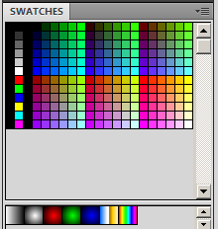

31. Select Window > Color to bring up the Color panel. Select Linear from the Type drop down box.
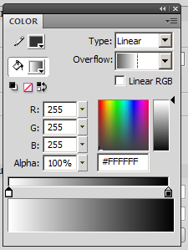

32. Double-click on the first Edit Gradient Range icon (the one on the left). Color boxes will appear. Select a blue color of your choice.

33. Double-click on the second Edit Gradient Range icon (the one on the right) and choose white (or black if you want to make a nighttime sky).

34. Click and drag the second Edit Gradient Range icon to the three-quarter point on the slider.

35. Select “no color” for the stroke on the Color panel.
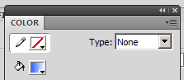

36. Click on the Menu Options icon at the top right corner of the Color panel and choose Add Swatch. Now it is added in with the color swatches at the bottom of the swatches tab.
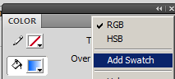

37. Make sure you still have the Rectangle tool selected. Also make sure that the stroke is set to “no color” and that the fill is set to the new blue gradient you created.
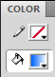

38. Click on the canvas and drag diagonally to create a rectangle in the sky (it should not cover the entire sky yet!).
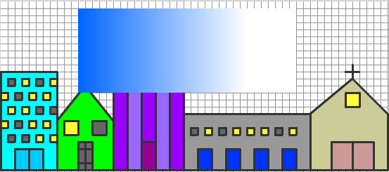

39. Click on the black selection arrow and click once on the sky to select it. Then choose Modify > Transform > Rotate 90° CW.
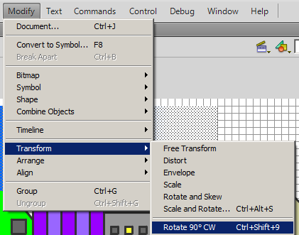
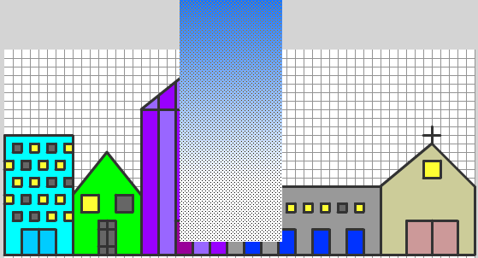

40. With the sky still selected go to Modify > Transform > Scale and expand the sky to cover up the entire background.

41. Click on the Sky layer in the Timeline and drag it downward to place it below the Buildings layer so the sky is behind the buildings.
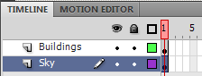

42. Next we need to add grass (or a sidewalk if you choose) in front of our buildings. Click on the black selection arrow and then click once on the Buildings layer in the timeline to place the grass on this layer. Click anywhere off the canvas to deselect the buildings.

43. Select the Rectangle tool on the toolbar and make sure the stroke is set to “no color” and select green for the fill color.
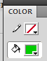

44. Draw a rectangle below the buildings for the grass.
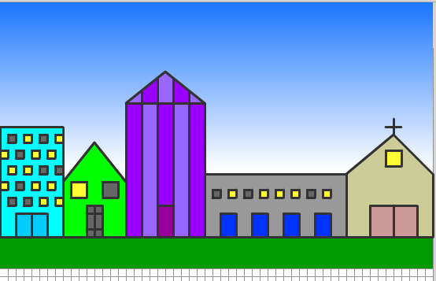

45. Next you need to add a road for the vehicle that you created to travel on. Make sure the Rectangle tool is still selected and chose a gray color for the fill. Draw a rectangle that covers the rest of the bottom of the canvas to make a road.

46. Now you will add the car to the canvas. Create a new layer by selecting Insert > Timeline > Layer. Double-click the new layer and name it Car.
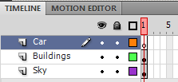

47. Click on the Library tab and then click and drag the icon beside the Car symbol to your canvas. If you want to change the size of your vehicle, do that now! Go to Modify > Transform > Scale and resize it.

48. Finally it is time to make the vehicle travel down the road. Click on frame 1 on the Car layer. Select the black selection arrow from the toolbar. Click and drag the vehicle off to the right side (or the left depending on which way you drew it).

49. Click on frame 60 on the Car layer and press F6 to add a keyframe.
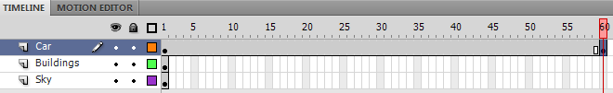
50. Hold down SHIFT and drag the car to the other end of the road. This puts the vehicle on the other end of the road on frame 60. Click back on frame 1 on the car layer and right-click and choose Create Classic Tween. This “tweens” the vehicle between frame 1 and frame 60.
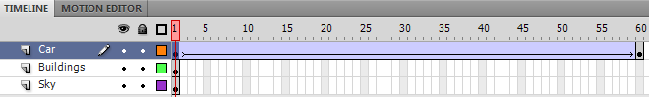

51. Click on frame 60 on the Buildings layer and press F5 to add frames. This keeps the Buildings layer present for 60 frames.
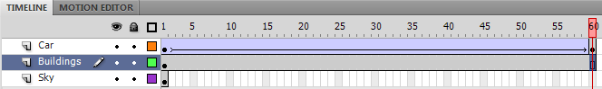

52. Lastly, click on frame 60 on the Sky layer and press F5 to keep it present.
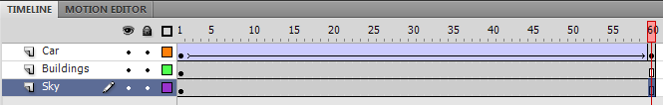

53. You are done! Press Enter to preview your animation.

Save as: “your name” City Animation.fla

